Lab 1 The Usage of Basic Commands

Goal: The students should understand and master the skills of using basic commands of UNIX/Linux system after having finished this lab. This lab will cover basic commands related to log in the system, change password, look up the information of the user, edit text files, switch to another user, check out the date and calendar, get built-in help, etc.

1.1 Logging in the system
The typical Linux desktop or workstation system will have 7 virtual consoles, one of them is graphical console, the others are character consoles, but there is usually no graphical console for a Linux server system.
We will practise how to log in the Linux system on these virtual consoles which are named from tty1 to tty7, and learn to switch from one console to another.
- The shortcuts to switch consoles are Ctrl+Alt+F1-F6. Press and hold the Ctrl key and Alt key at the same time on the keyboard, don’t release them, then press F1 for tty1, or F2 to F7 for tty2 to tty7. The tty7 is graphical console. If the Linux system is installed on a VMWare virtual machine,you should . Press and hold the Ctrl key and Alt key at the same time, don’t release them, then press and release the SPACE key, then press F1 for tty1, or F2 to F7 for tty2 to tty7. Please be aware that the Ctrl key and Alt key should be held all the way.
- Logging in the Linux system on a character console with the usernames student and root. The password for student is same as the username student, the password for root is redhat.

Station1 login:student ------->here input the username:student
Password: ------->here input the password, the password will not be
echoed on the screen, for the consideration of
securities.
student@station1:~$ ------->the command prompt sign appears after logging in
successfully, the prompt is composed of username
student, @ character, workstation name station1,
semicolon character, current working directory ~
and $ character. The last character $ means that the
user who logged in is a non-privilege user. If the
user logged in is a superuser, the last character
would be # character

Station1 login:root
Password:
root@station1:~#

1.2 Changing password
The passwd command in Unix/Linux is used to change the user account passwords. The root user reserves the privilege to change the password for any user on the system, while a normal user can only change the account password for his or her own account.

- The scenario of changing password successfully. The user should input the current password before he or she can input the new password. The new password should be input twice.

student@station1:~$ passwd
Changing password for user student.
Changing password for student
(current) UNIX password
New UNIX password:
Retype new UNIX password:
passwd: all authentication tokens updated successfully.
- The scenarios of failing to change password due to use a bad password. The new password shouldn’t be too simple according to the police of password setup by superuser.
student@station1:~$ passwd
Changing password for user student.
Changing password for student
(current) UNIX password:
New UNIX password:
BAD PASSWORD: It is based on a dictionary word

New UNIX password:
BAD PASSWORD: it is based on a dictionary word
Passwd: Authentication token manipulation error

- Superuser(root) changes his or her own password .
  - First step, switch to superuser

student@station1:~$ su –
Password:

  - Second step, use passwd command to change password. The superuser(root) can use any string as new password, needn’t meet the password policy about complexity.

root@station1:~# passwd
Changing password for user root.
New UNIX password:
BAD PASSWORD: it is based on a dictionary word
Retype new UNIX password:
passwd: all authentication tokens updated successfully.

- Superuser(root) has the privilege to change password of any other user. Regular user (non-privilege user) only can change his or her own password, has no privilege to change other users’ password.
root@station1:~# passwd student
Changing password for user student.
New UNIX password:
BAD PASSWORD: it is based on a dictionary word
Retype new UNIX password:
passwd: all authentication tokens updated sucessfully.

Notice: it will make other students can’t use the system, if you changed the password of the account of student or root on the system in our laboratory. Please make sure that you do change the password back to the original one if the you changed it.

- The scenario of change password under GUI environment. Click the the sign of down arrow at the up-left corner of the screen, then select the Setting menu item, as shown in Fig. 1. In the popup window, click the Users item in the left panel, then click the Password item in the right panel, a dialog will show up for the user to change password, as shown in Fig. 2.
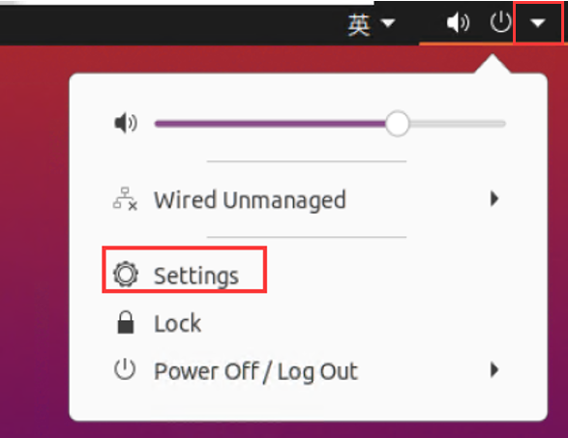
Fig 1 The position of settings menu item
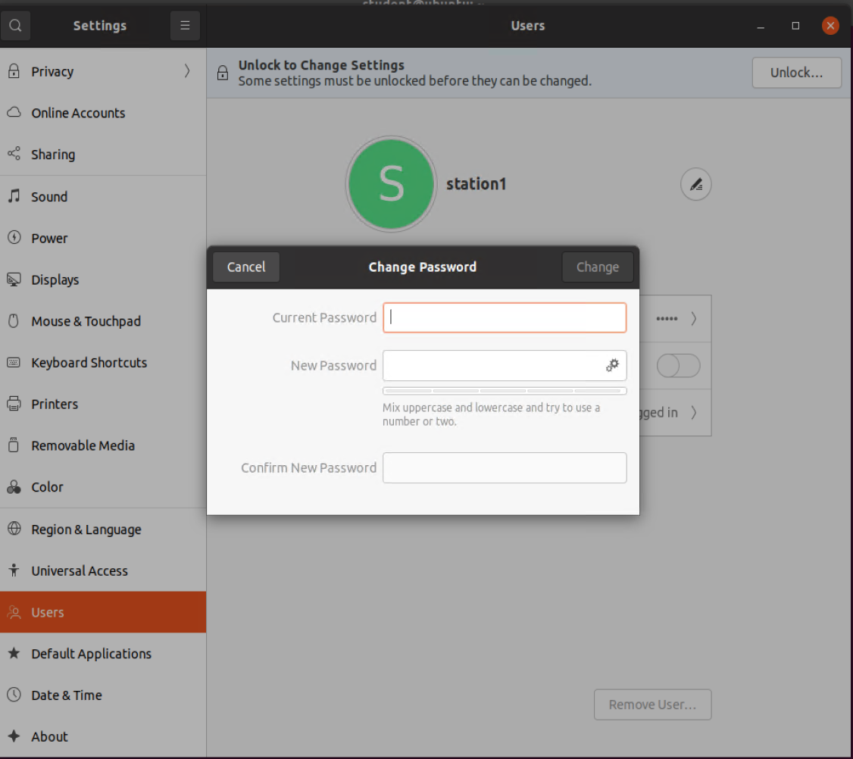
Fig 2 the dialog of changing password

1.2 finding out the information of accounts and switching between different accounts

- The id command that used to find out the information of current logged-in user
root@station1:~# id
uid=0(root) gid=0(root) groups=0(root), 1(bin), 2(daemon), 3(sys), 4(adm), 6(disk), 10(wheel)
context=root: system_r: unconfined_t: SystemLow-SystemHigh

The current logged-in user is root
student@station1:~$ id
uid=1000(student) gid=1000(student) groups=1000(student), 4(adm),24(cdrom),27(sudo), 30(dip), 46(plugdev),120(lpadmin),132(lxd),133(sambashare)

The current logged-in user is student。

- The su command to switch between different users
To switch from the user student to the superuser root by su - command.
student@station1:~$su -
Password:
root@station1:~#

Quit from the superuser root to the user student by using exit command.

root@station1:~#exit
student@station1:~$

1.2 Editing plain text file, the basic usage of editor Nano
Nano is a plain text editor with command line interface. Please use nano command to create a new text file named test.txt, then input some stuff to the file and edit it, furthermore use Ctrl+O shortcut to save the file, finally user Ctrl+X shortcut to quit the editor.

First, use command nano test.txt to open a new file named test.txt with nano editor. The interface of the nano editor will appear as shown in Fig 3.

student@station1:~$ nano test.txt

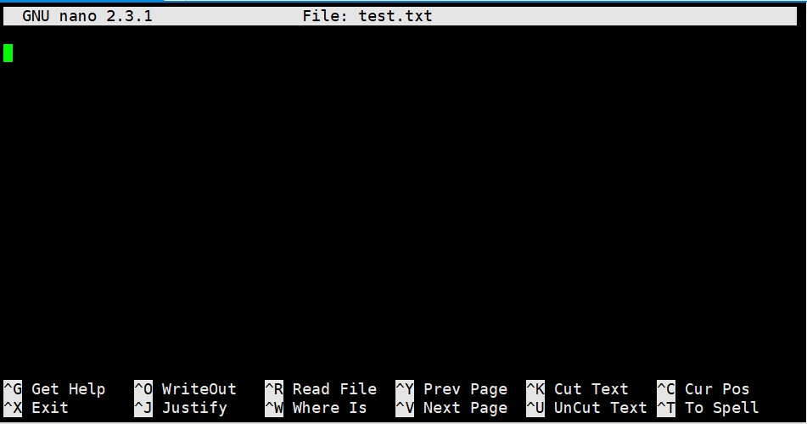
Fig 3 the interface of the nano editor
The two lines of the information about the shortcuts of the editor at the bottom of the interface. The ^ sign stand for Ctrl key on the keyboard. ^O stands for WriteOut, as same as save to file, ^Y stands for PageUp, ^V stands for PageDown , ^K stands for Cut Text, ^X stands for Exit.
You can see the new created file test.txt under the current directory by using ls command after saving the file and exiting nano.。

student@station1:~$# ls
anaconda-ks.cfg install.log install.log.syslog test.txt.

1.3 The usage of date command
- The date command used to display current date and time of system.

student@station18~]$ date
Wed Oct 28 11:51:33 CST 2020

To display date and time in specified format using the following command.

student@station18~]$ date +"Today is %A, %B %d, %Y.%nIt is %r, %Z"
Today is Wednesday, October 28, 2020.

It is 12:02:26 PM, CST
- The date command used to change current date and time of system, this task will require the privilege of root user.

root@station18~]# date 102812212020.20
Wed Oct 28 12:21:20 CST 2020

1.4 The usage of cal command
- To display the calendar of current month

student@station18~]$ cal

- To display the calendar of specified month

student@station18~]$ cal 9 2009
1.4 Getting help
- the --help option of command will show the brief usage of the command

student@station18~]$ date --help
Usage: date [OPTION]... [+FORMAT]
or: date [-u|-utc|--universal] [MMDDhhmm[[CCJYY][.ss]]
…………….

Every command has the --help option in Linux system. In the usage of commad, the [] means the item in the brackets is optional, the … means the item could appear repeatedly, the x|y|z means one of the several items, the -abc means the combination of several options, such as -abc stands for -a –b -c , -ab stands for -a -b, –bc stands for -b -c , -ac stands for -a -c.

- The man command
The man command is used to lookup the usage of command in built-in manual in system. The built-in manual is created by the developer of the command, which describes the usage of the command in detail. There are about eight chapters of the built-in manual as followings.
- User commands, the manual about commands for end users.
- System Calls, the manual about how to invoke system calls
- Library calls, the manual about the DDL library.
- Special files, the manual about device files.
- File formats, the manual about the formats of system configuration files.
- Games, the manual about the preinstalled game.
- Miscellaneous, other manuals, such as network protocols, file systems etc.
- Administrative commands, the manual about commands for system administrators.

The usage of man command: man [<chapter>] command

To look for the manual page about the passwd command by using the following command.

student@station18~]$ man passwd

To quit man command by pressing the q key on keyboard.

To look up the manual page about the format of the passwd file by using the following command.

student@station18~]$ man 5 passwd

